# EMPLOYEE APPRECIATION BASED ON CUSTOMER SATISFACTION

**Team members:**

Allam Yamini Divya

Gumma Anusha

Kola Manikanta

Meriga Sricharan

**Introduction:**

This project is useful for the companies to identify the employees who are giving their best in order to satisfy customer needs. Employees who are working efficiently will be appreciated based on their performance. If the customer is satisfied with the employee then he will be appreciated based on his performance.

**Literature survey:**

Existing problem:

Today most of the companies are struggling to find the best employee because it is hard to find out each employee performance. In order to appreciate an employee they are struggling a lot.

Proposed solution:

For this problem we are proposing a solution that analyzes the employee by using this service which is used to find out the best employee based on his performance.

**Code screenshots:**

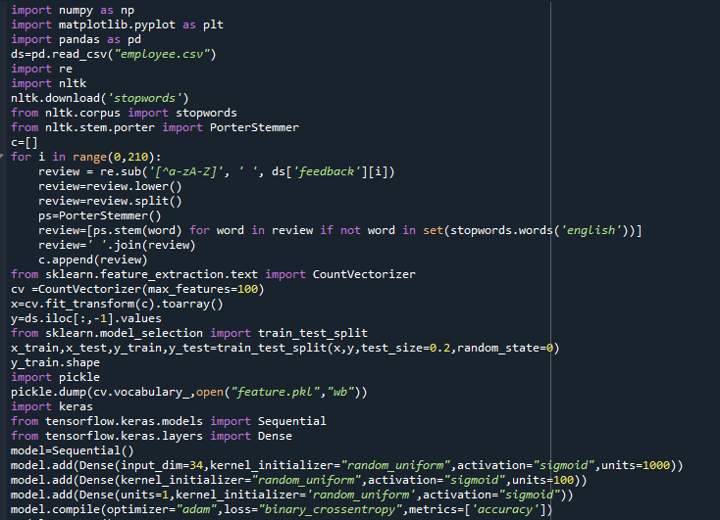

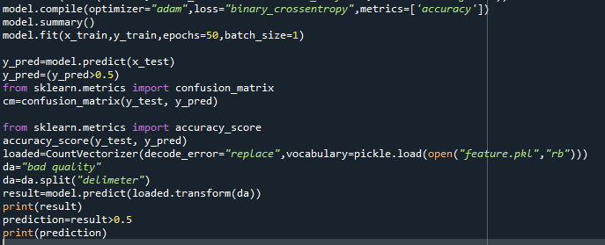

**Output screenshots:**

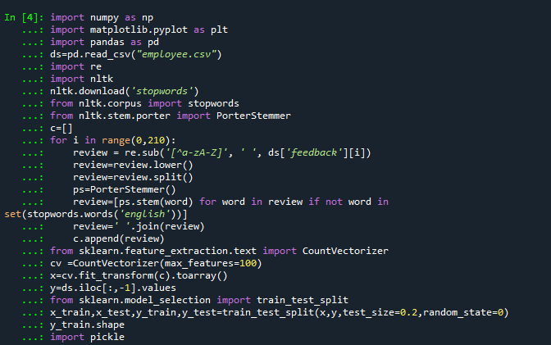

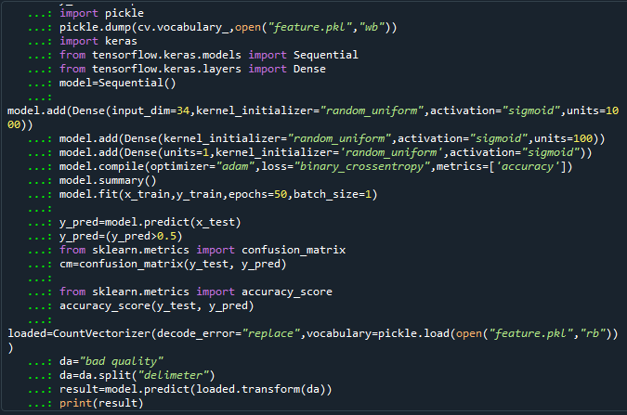

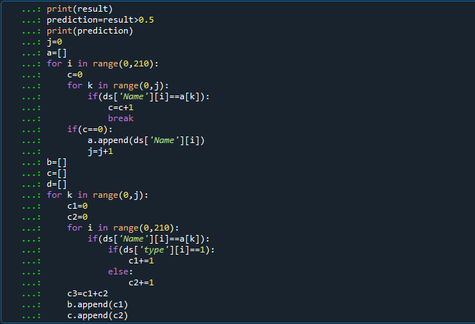

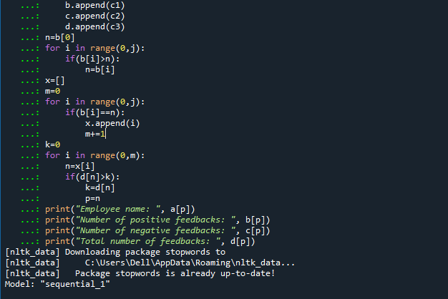

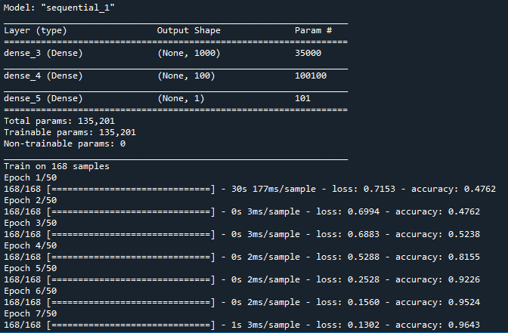

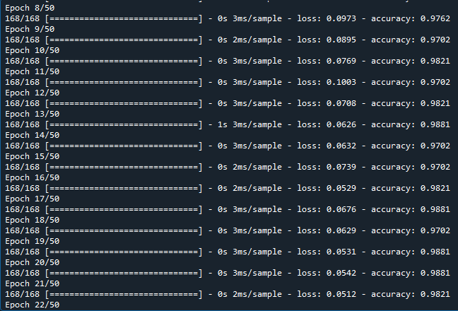

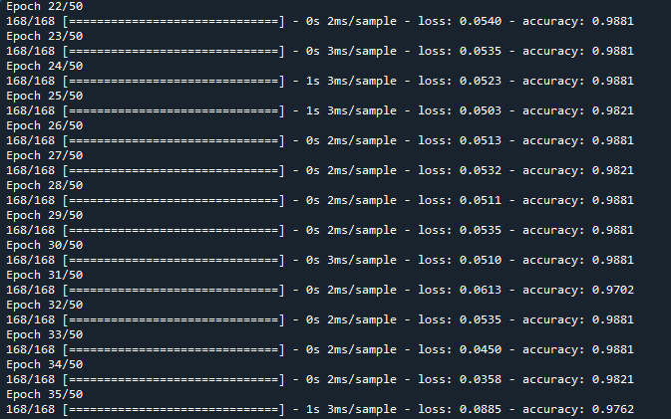

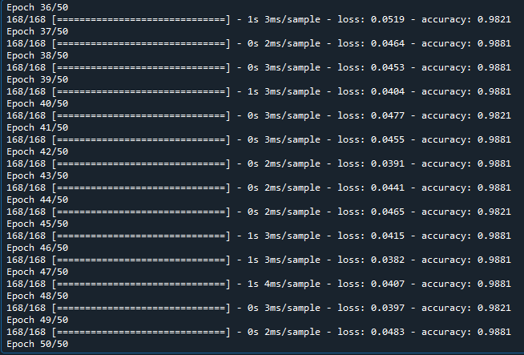

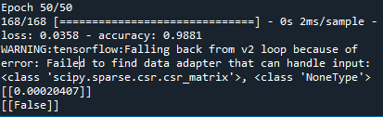

**Result:**

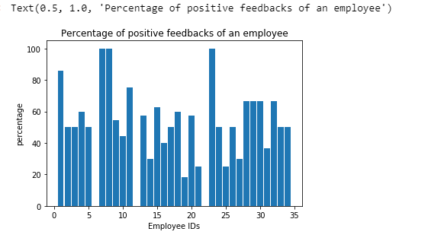

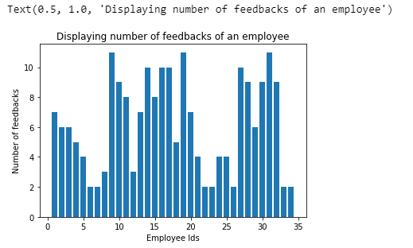

**Advantages:**

* It is easy for the companies to choose best employee based on his performance.
* The employee is appreciated based on his performance.
* Employee performance is based on customer satisfaction.
* If the customer is well satisfied he will be appreciated.
* It is necessary to appreciate the employees in order to make them work efficient.

**Dis advantages:**

* It is hard to find out the best employee if more than one employee got the same performance.
* So that we have to find out the best among them.

**Applications:**

It can be applicable for the companies where the companies need to satisfy their customers.

**Conclusion:**

It is important for the companies to make sure that their customers are satisfied or not so every employee needs to work efficiently in order to satisfy the customers. So those employees need to be appreciated based on their performance. So this service helps companies to find the best employees easily based on customer satisfaction.

**Future scope:**

This service will be most useful for future generations as they will find this task so difficult in their busy life. This service will be very helpful for them in order to find the best employee.